2023 S1 ELEC3042 Major Project Design Review

Name: Tyler Johnson

Student ID: 46978518

**1. State Machine Design**

1. Show the state diagram(s) and state transition table(s) that describe the main phases of traffic for the Main Street/School Road intersection, and how the individual traffic lights change. Handwritten state diagrams and transition tables will not be accepted.

|  |  |  |  |  |  |  |  |
| --- | --- | --- | --- | --- | --- | --- | --- |
| CURRSTATE | INPUTS | | | | | NEXTSTATE | OUTPUT |
| MSS/MST/SRM | S1/S0 | S2 | S3 | S6 | MSS/MST/SRM |
| Main State | 0/0/0 | X | X | X | 0 | MSS | 0/0/0 |
| Main State | 1/0/0 | X | 1 | X | 0 | MST | 1/0/0 |
| Main State | 1/1/0 | X | X | 1 | 0 | SRM | 1/1/0 |
| Main State | 1/1/1 | X | X | X | 0 | Main State | 0/0/0 |
| Main State | 1/0/1 | X | X | X | 0 | Main State | 0/0/0 |
| Main State | 0/1/1 | X | X | X | 0 | HAZ | 0/0/0 |
| Main State | 0/1/0 | X | X | X | 0 | HAZ | 0/0/0 |
| MSS | 0/0/0 | X | 0 | 0 | 0 | MSS | 0/0/0 |
| MSS | 0/0/0 | X | X | X | 0 | Main State | 1/0/0 |
| MST | 1/0/0 | X | X | X | 0 | Main State | 1/1/0 |
| SRM | 1/1/0 | X | X | X | 0 | Main State | 0/0/0 |
| X | X/X/X | X | X | X | 1 | HAZ |  |
| HAZ | X/X/X | X | X | X | 0 | Main State |  |

**MSS/MST/SRM** Refers to 3 flags for their respective phases. They have been combined to save page space.

Due to the nature of intersections, a sensor detecting traffic will only turn off if the traffic in that lane is cleared. For example, if we are in state MSS and the sensor S3 is triggered it will only stop being triggered once that traffic is cleared. This means that once we are out of MSS the sensor should still be triggered, pushing us into the corresponding traffic phase (SRM). Once SRM goes green and the traffic is cleared the sensor will not be triggered, and if no other sensors are triggered, we move back to our MSS state (Default operation).

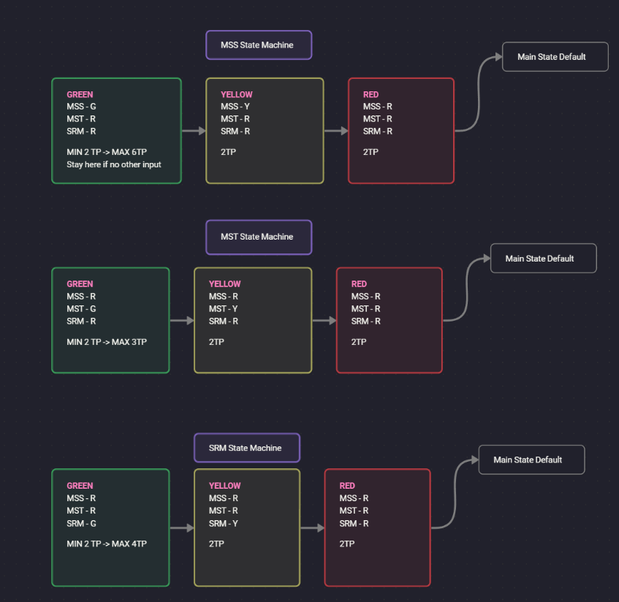

**MSS STATE MACHINE:**

|  |  |  |  |  |  |  |  |  |
| --- | --- | --- | --- | --- | --- | --- | --- | --- |
| CURRSTATE | INPUTS | | | | NEXTSTATE | OUTPUTS | | |
| S0/S1 | S2 | S3 | S6 | MSS | MST | SRM |
| G | X | 0 | 0 | 0 | G | G | R | R |
| G | X | 1 | 0 | 0 | Y | G | R | R |
| G | X | 1 | 1 | 0 | Y | G | R | R |
| G | X | 0 | 1 | 0 | Y | G | R | R |
| Y | X | X | X | 0 | R | Y | R | R |
| R | X | X | X | 0 | Main State | R | R | R |
| X | X | X | X | 1 | HAZ | Y | Y | Y |

**MST & SRM STATE MACHINE: (These states are very similar)**

|  |  |  |  |  |  |  |  |  |
| --- | --- | --- | --- | --- | --- | --- | --- | --- |
| CURRSTATE | INPUTS | | | | NEXTSTATE | OUTPUTS | | |
| S0/S1 | S2 | S3 | S6 | MSS | MST | SRM |
| G | X | X | X | 0 | Y | G | R | R |
| Y | X | X | X | 0 | R | Y | R | R |
| R | X | X | X | 0 | Main State | R | R | R |
| X | X | X | X | 1 | HAZ | Y | Y | Y |

Inputs in these states only affect Green state duration. In the MSS state machine, green can potentially go on forever so long as there is no other traffic detected.

**NOTE: All lights can only be one color, assume all other lights other than the light specified are turned off.**

1. If you are in the default phase and all sensors are triggered, what is the order of the phases of traffic according to your state diagrams? Why have you chosen this order? Have you considered any other alternative order?

**MSS -> MST -> SRM**

I chose this order as it makes sense to try and let as much traffic through Main Street as possible. Since cars cannot turn right off main street northbound until MST phase, they will queue up during MSS. It also makes sense as MST has the shortest max time, and since they would have to wait for potentially 6TP, it makes sense to let MST go next. I considered MSS -> SRM -> MST as an alternative order, but traffic from SR is already slowed by both the pedestrian crossing and school zone. Not as many cars would be approaching from SR as frequently, and fewer cars will be queueing at the intersection as there isn’t as much space.

**2. Timers**

How do you plan to use the hardware timers? Why was this timer chosen for this purpose?

|  |  |  |
| --- | --- | --- |
| Timer | Purpose | Justification |
| Timer0 | secTimer | Highest resolution – Keeps time while asleep |
| Timer1 | Speaker | Speaker is connected to PB1 as per the wiring diagram – Set to CTC mode |
| Timer2 | Serial Data | Reserved for being the clock signal to interface with the port expander |

**3. Interrupts**

How many interrupts do you plan to use and what will they be used for?

|  |  |
| --- | --- |
| Interrupt | Purpose |
| INT1 | Pedestrian Crossing Input (S4) |
| INT0 | Stops all other phases and reverts to HAZ (S6) |
|  |  |

**4. Code**

*Add any code you have written so far.*

**I have not yet written any code specific to this project, as I wanted to receive feedback on my design before commencing.**